Paper Title

Guidelines for Technical Summary to submit 3DSA in the 23rd International Display Workshops

Names of All Authors with Their Affiliations

Do not remove this “3DSA”   
if you want to present in 3DSA.

Hideya Kumomi, Harumi Kawamura*, Toshimitsu Tsuzuki**, Ken Ishikawa

Tokyo Inst. of Tech., Japan, * NTT, Japan, **NHK, Japan

Abstract

Attach 50 words or less abstract for reviewing here. The technical summary consists of one- or two-page text in one column, with additional pages for figures/tables/photographs. It is used for evaluation only and will not be published.

Topics of Scope/Special Topics of Interest Preference

Please indicate a Topic of Scope or Special Topic of Interest (STI), in which you prefer to make the presentation. If your paper relates to interdisciplinary topics, you can choose two. If you want to be an attendee of 3DSA, please select the Special Topics of Interest “ AR/VR and Hyper Reality ”or the scope“ 3D/Hyper-Realistic Displays ” The final decision will be made by the Program Committee.

Presentation Style Preference

Your presentation preference should be indicated (Oral | Poster | Poster Only | Either). If you will not accept an oral presentation, please choose "Poster Only". The final decision will be made by the Program Committee.

Prototype Demonstration Preference at Innovative Demonstration Session

Please indicate if you wish to show your prototype demonstration at the Innovative Demonstration Session, which provides a larger display space and allows more time for preparation and demonstration than the Author Interviews and Demonstration. (Yes/No.)

Body of Technical Summary

Body of Technical Summary covers background and objectives, results, originality, impact, references, and prior publications.

*Page style and size*: One- or two-page text in one column, with additional pages for figures/tables/photographs. Technical Summary should be formatted in **A4**-**sized** or **letter-sized** pages.

*Font sets*: Use standard English font sets for the entire of your Technical Summary, for example **Times New Roman, Times, Arial and Helvetica**. In addition to these, **Symbol,** **Wingdings** or **ZapfDingbats** is strongly recommended for typing any math functions and Greek symbols. These special symbols can be inserted by using the insertion function of "symbols and special characters" on the Microsoft Word menu. Greek alphabet and mathematical symbols in **Symbol**:  αβχδφγηϕκλμνπθστωξψζ∂○✗✓ can be found in Wingdings. Please expresses the sign [°C] by a combination of [°] and [C] in the standard font.

*File size*: A less than 1 MB file size is recommended. Your network gateway may have a limitation of an uploading file size.

*Header*: Include the presenting author’s name and title of the paper on the header line in each subsequent page. Put the page number on the right side on the header line.

Submission format: Technical Summary submission via our website can be accepted in **PDF format without any security options**.

*Figures, tables, and photographs*: Place the all figures/tables/photographs **at the end of the text** to prevent layout disorder when reviewing. For reducing the file size, we recommend that the photographs in your Technical Summary are pasted in **JPEG** format.

# Background and objectives

Introduce the state of the subject and describe the goal of your work.

# Results

Describe specific results. Illustrations to highlight your work are encouraged.

# Originality

Clearly describe what are new and/or emphasized points.

# Impact

Discuss the significance of your work and compare your findings with previously published works.

# References

1. List references covering projects in related areas.

# Prior publications

1. The paper must be an original contribution. If you have published or presented material for similar work, explain how the present material differs.

Table 1 Figures/tables/photographs should be placed after the text of the Technical Summary

|  |  |  |
| --- | --- | --- |
| Sample | Value 1 | Value 2 |
| Material 1 | 54.3 | 45.6 |
| Material 2 | 48.6 | 34.2 |



Fig. 1 Title and terms on a figure

Title and other terms on figures are better to be re-written in clear large letters.

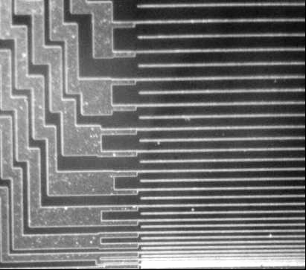

Fig. 2 File size reduction

For reducing the file size, we recommend that the photographs in your Technical Summary are pasted in JPEG format.

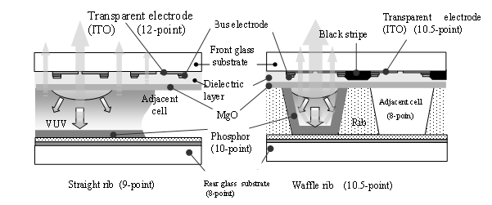

Fig. 3 Drawing with no-color figure and grouping (12-point Bold)

Too small letters or too fine lines are not good for reading. Not to use less than 8-point letters. In case of color figures, print out their black and white copies and check their legibility. For the evaluation, in sometimes, white and black copies of Technical Summary are used. (10-point)